R & D Challenges
- To Install Docker steps used to install docker in amazon-linux-ec2-machine command used is:
- Step1: Launch EC2 instance
- Step 2: Connect to instance
- Step3: Install docker by below command:
sudo yum install docker
- Step4: Start and checking the running status working or not.
sudo systemctl start docker
sudo systemctl enable docker
sudo systemctl status docker

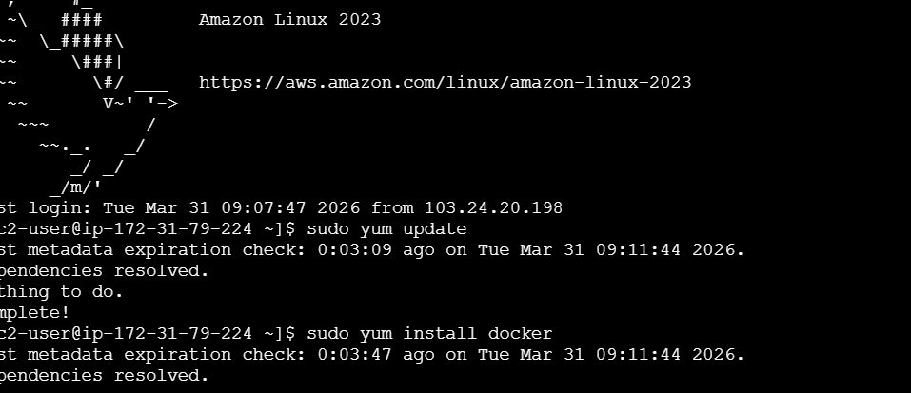
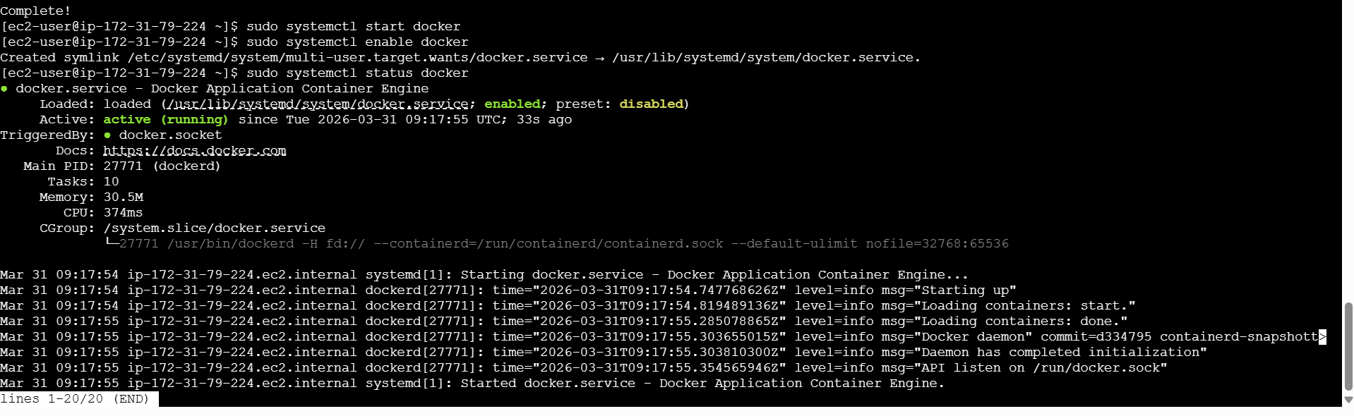

2.Install Apache(httpd):
- Sudo yum install httpd-install Apache
- sudo systemctl start httpd
- sudo systemctl enable httpd
- sudo systemctl status httpd
I have changed port to 8081

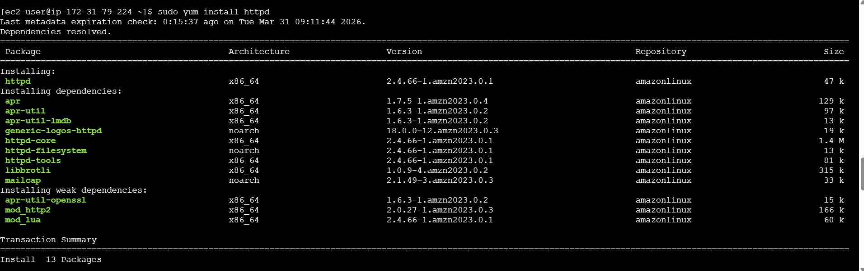
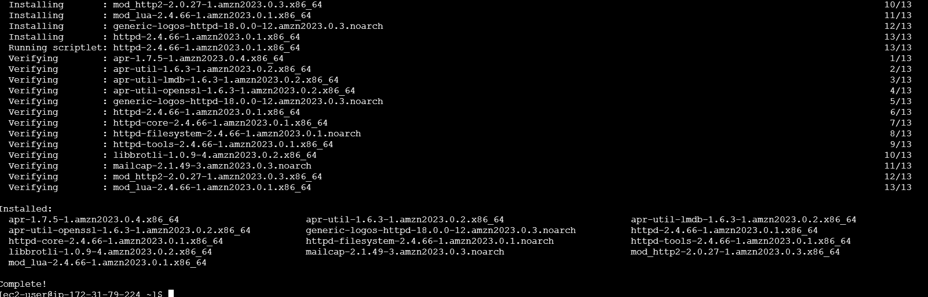
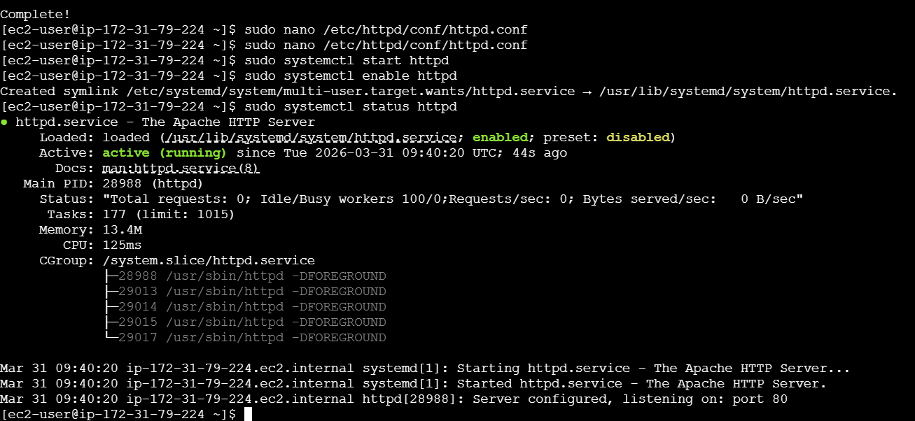

3.Install Jenkins
First, we need to install java is the most used prerequisite first of all try to install java using the command
Adding Jenkins repositories.
Imported Jenkins key.
Installed Jenkins.
- Sudo yum install java-17-amazon-corretto
sudo systemctl start jenkins
sudo systemctl enable jenkins
sudo systemctl status jenkins
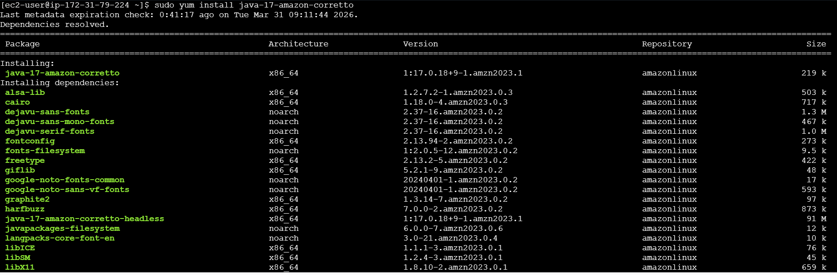
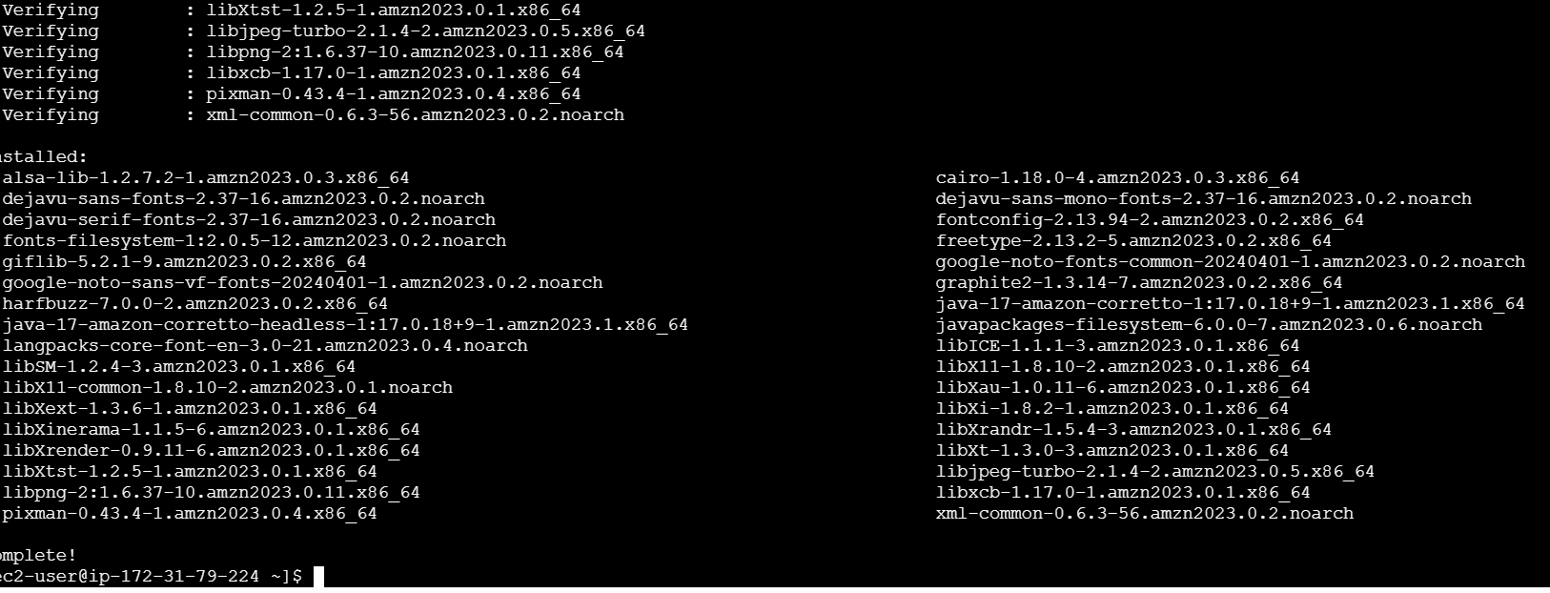
Downloading the Jenkins repo:
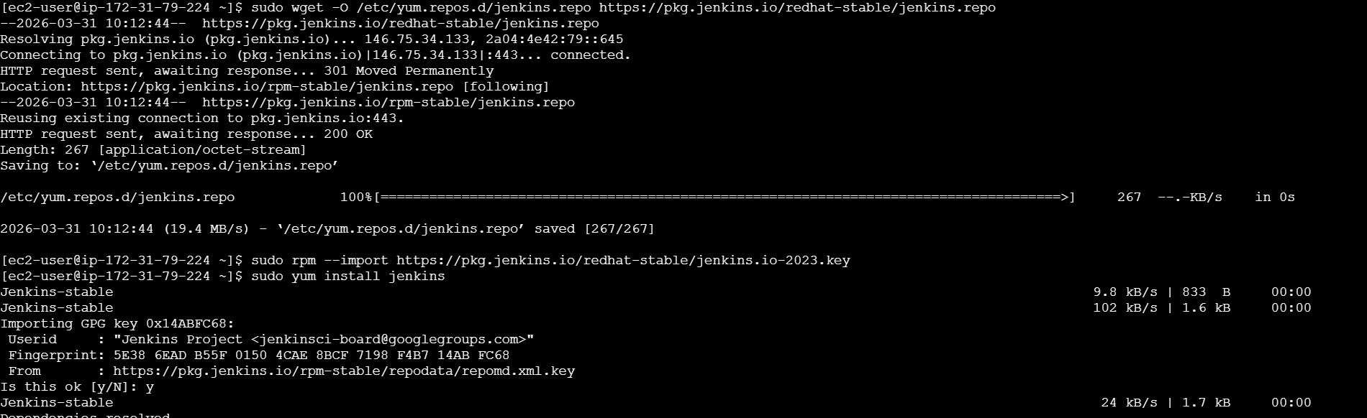
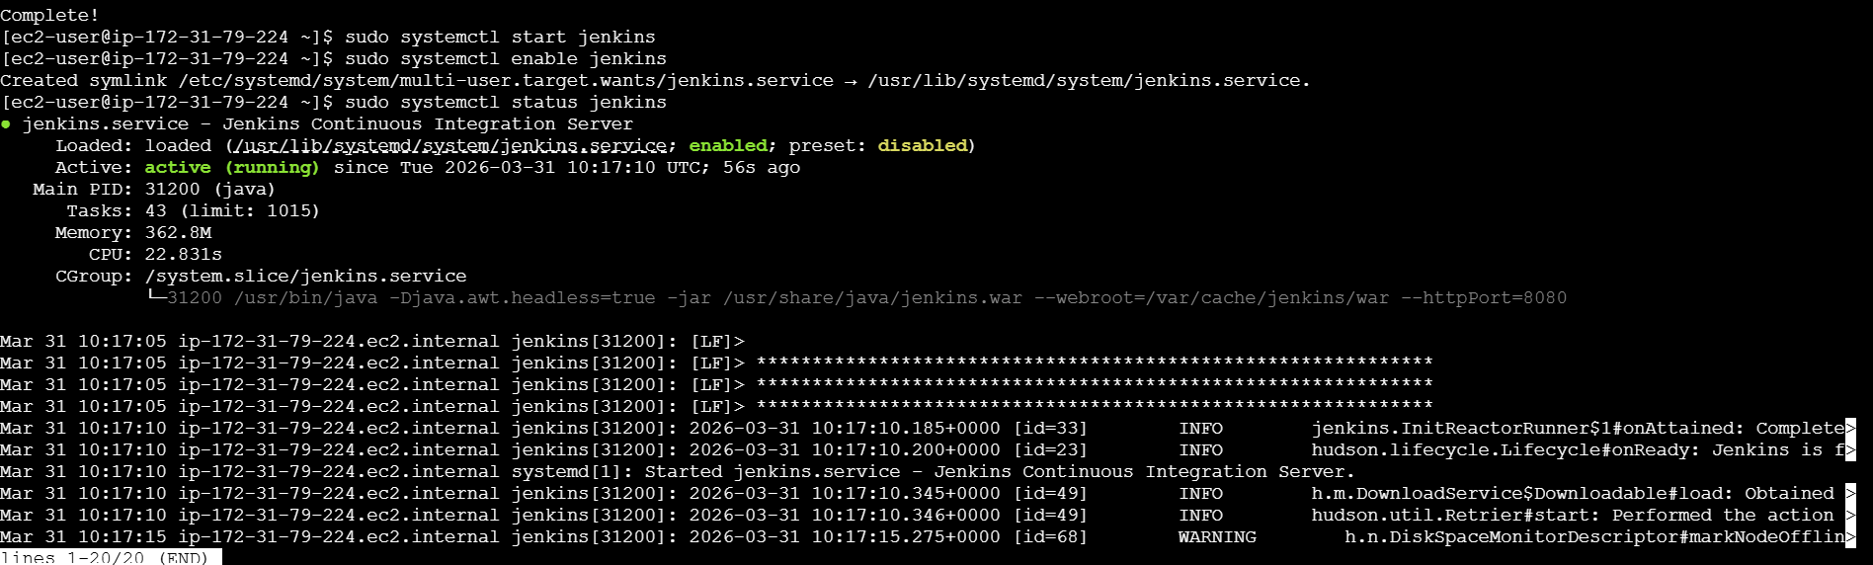
Configured the security group port number 8080
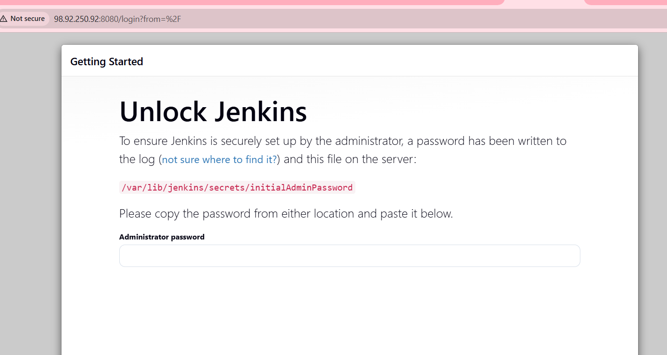
Jenkins is now installed.
4 Install nginx
- sudo yum install nginx
- sudo systemctl restart nginx
- Because here port number 80 changing to 81 number then nginx was restart again.
- When we have to use same httpd and jenkins at a same time we have a port numbers will be same that time we need to change the port number.we have to use change the port number we use this command:
- nano /etc/nginx/nginx.config
- Sudo systemctl enable nginx
- Sudo systemctl status nginx
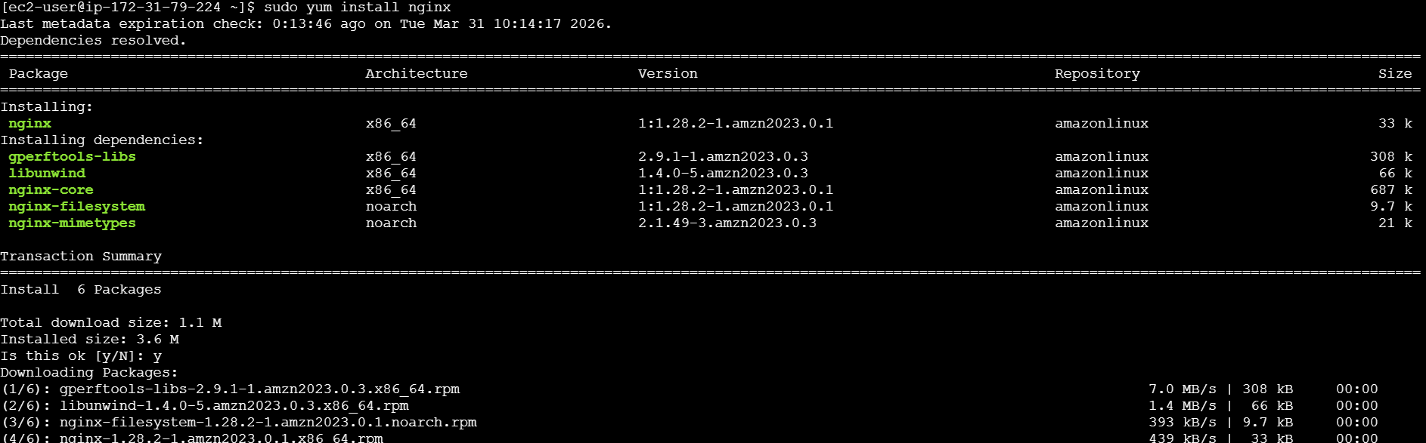
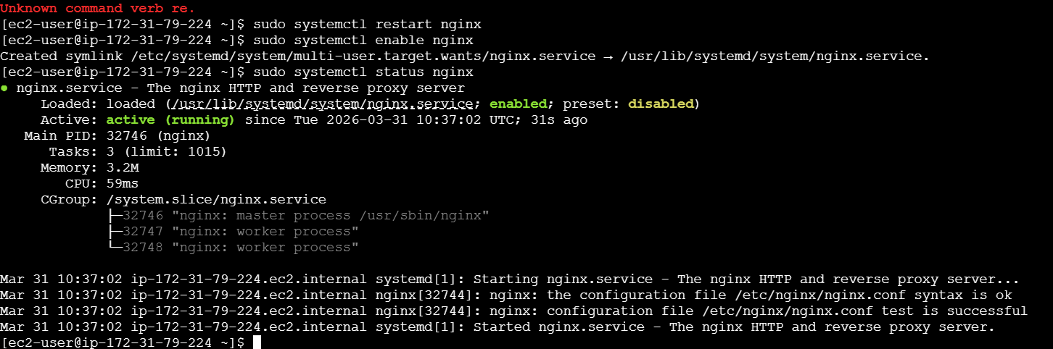
5. Install Apache Tomcat
- To use the following command
first use wget command to get download the package
wget https://dlcdn.apache.org/tomcat/tomcat-9/v9.0.116/bin/apache-
tomcat-9.0.116.tar.gz
- command so the server will start
(ii) Since we are using Jenkins and tomcat on same server and port need to
change the port number in tomcat using this location
Go To tomcat cd conf nano server.xml and change the connector port to
8081
Now since we changed the port number restart using command sh
shutdown.sh and start shutdown.sh

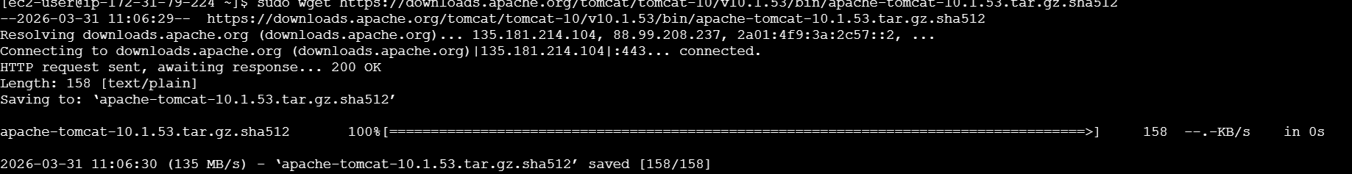
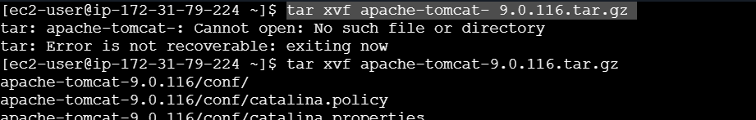
Renaming it:
